**NAM SET UP**

<https://docs.dynatrace.com/docs/observe/digital-experience/synthetic-monitoring/network-availability-monitors/create-a-nam-monitor#nam-api>

1. Select **Synthetic - Network availability monitors.**
2. Select Create a Network Availability Monitor

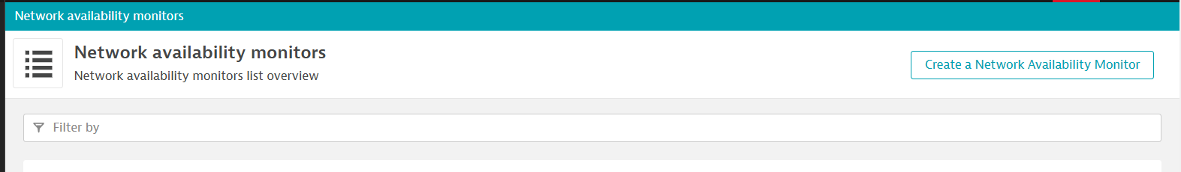

1. Enter Monitor name.

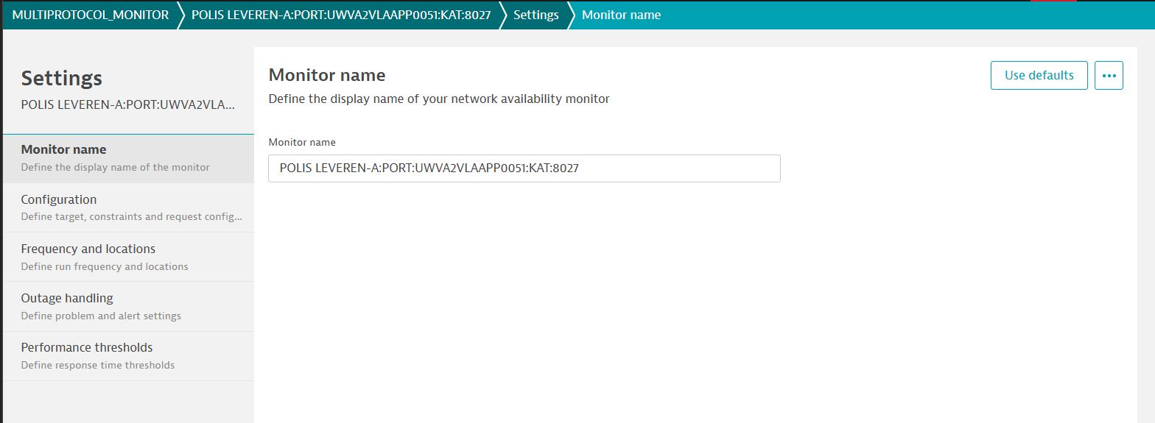

Save the config.

Click the configuration.

Enter the Monitor description: - My network availability monitor description.

Add Step

Step name: -

Step 1

Request type: -

TCP

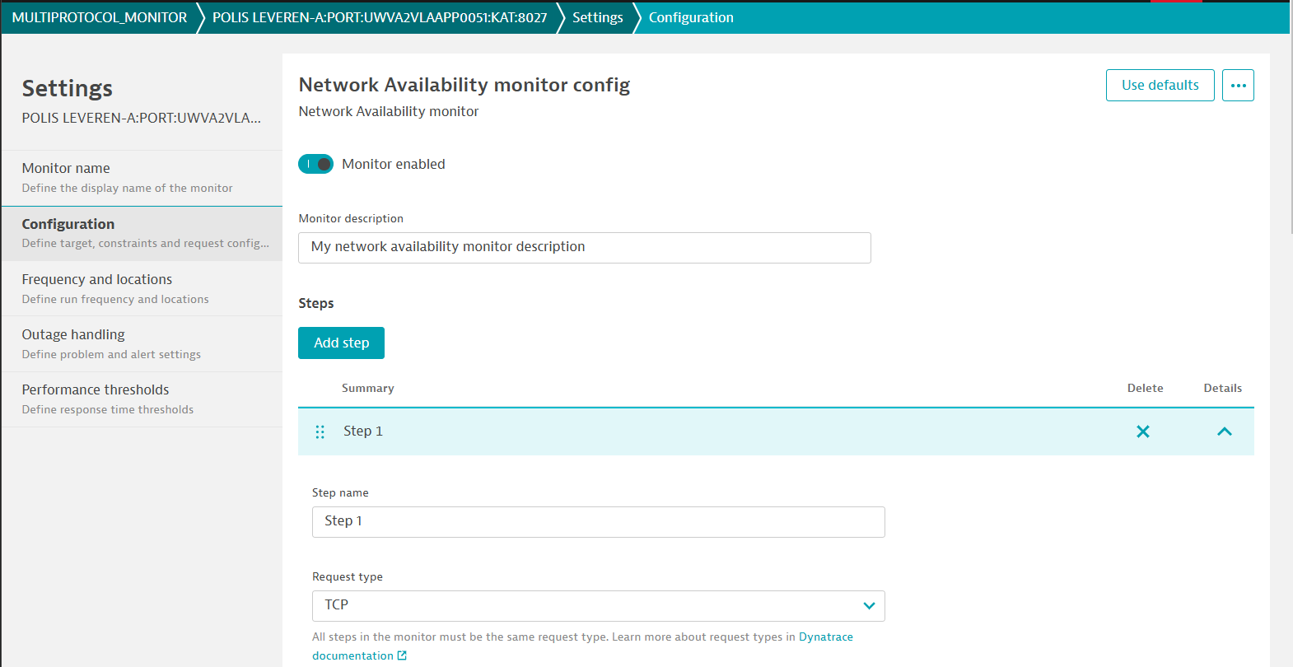

1. Add IP Address or DNS name.

Target addresses: -

10.0.0.0

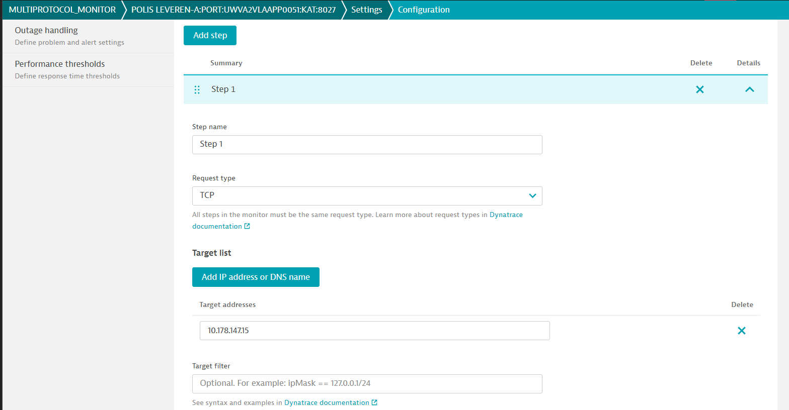

1. Configuration Properties

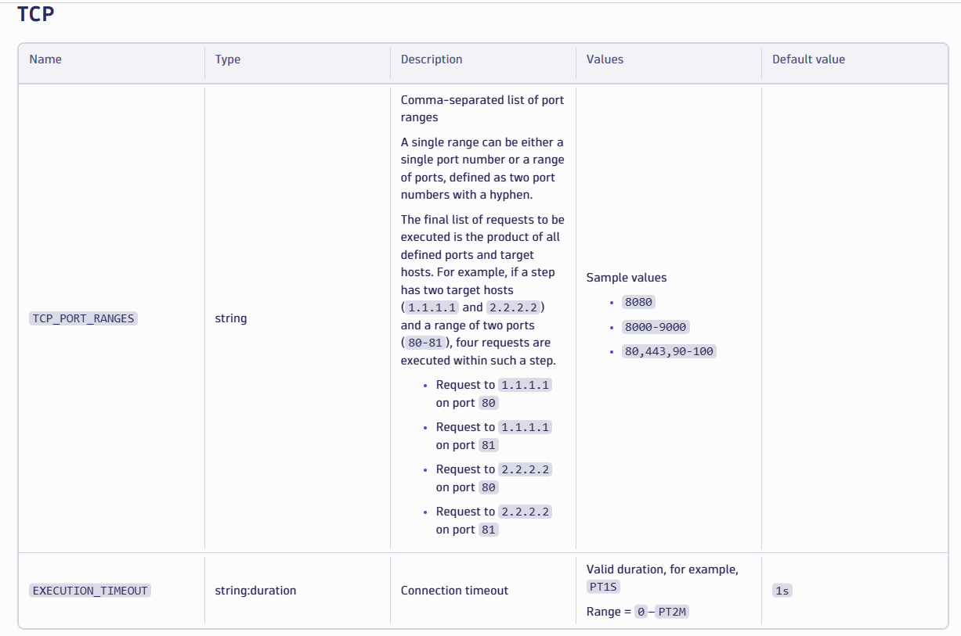

1. Add configuration Property.

Property key

EXECUTION_TIMEOUT

Property value

PT1S

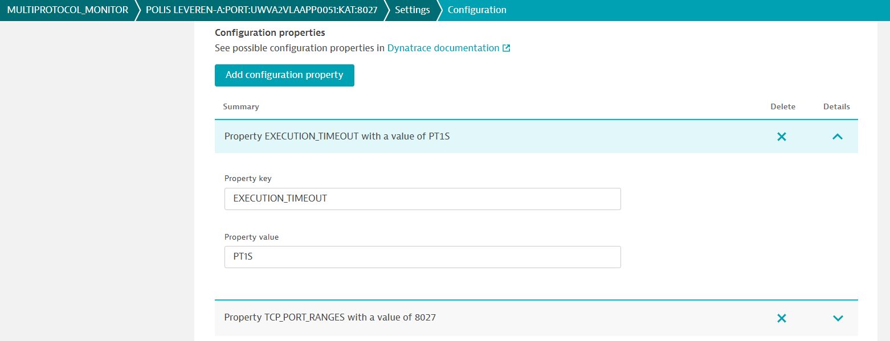

Property key

TCP_PORT_RANGES

Property value

8027

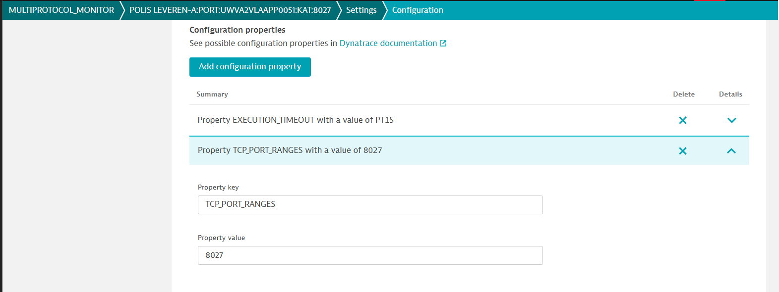

1. Step-level constraints.

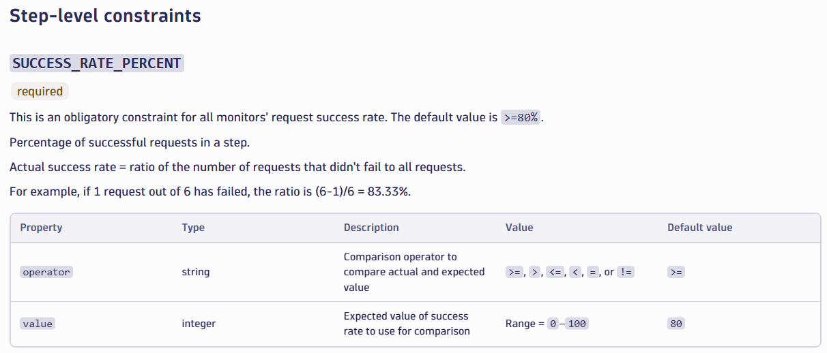

1. Add Step-level constraint.

Constraint type

SUCCESS_RATE_PERCENT

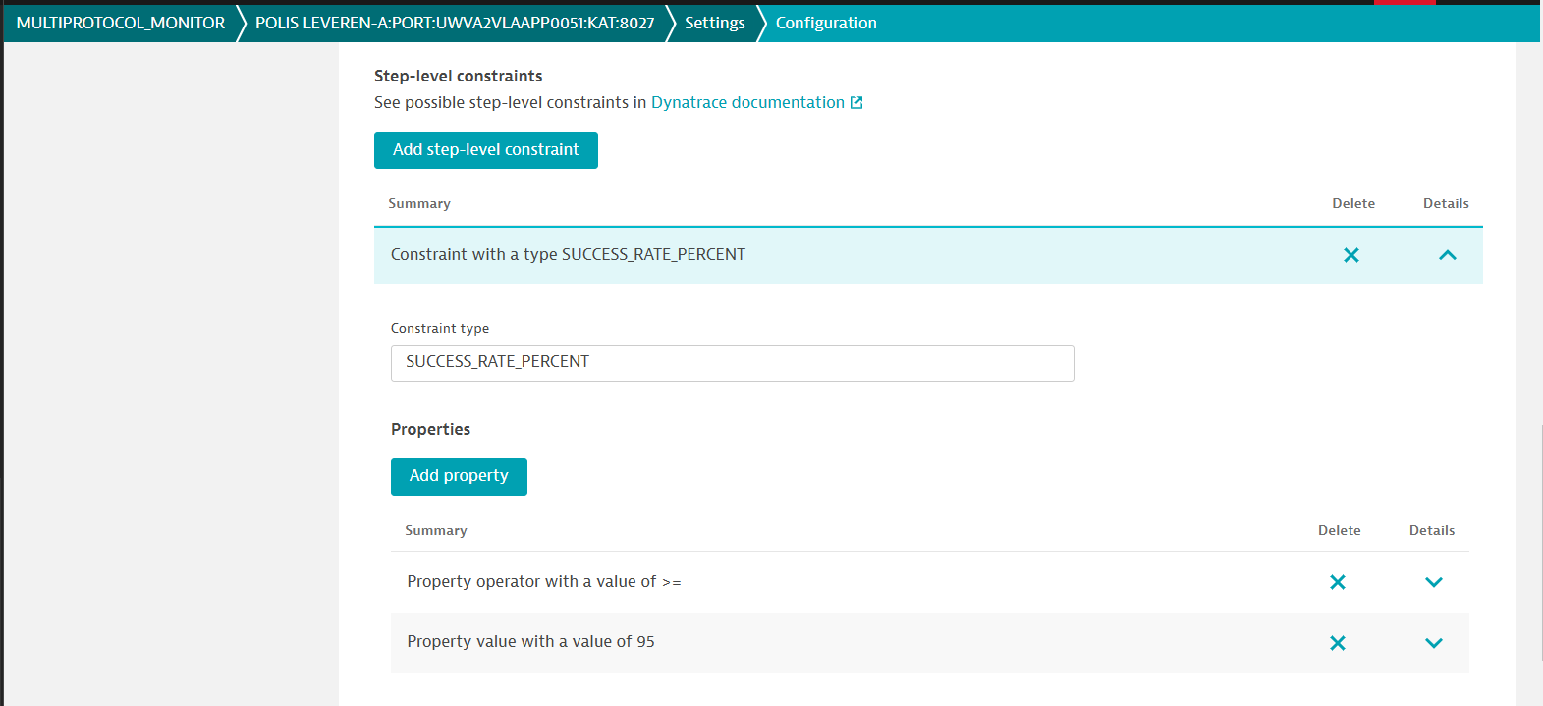

Property key

Operator

Property value

>=

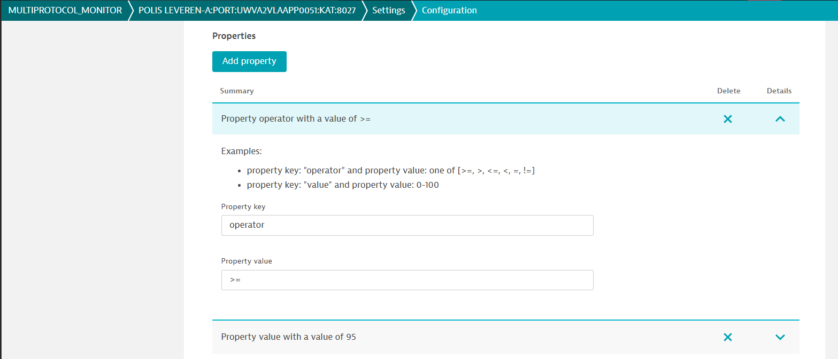

Property key

value

Property value

95

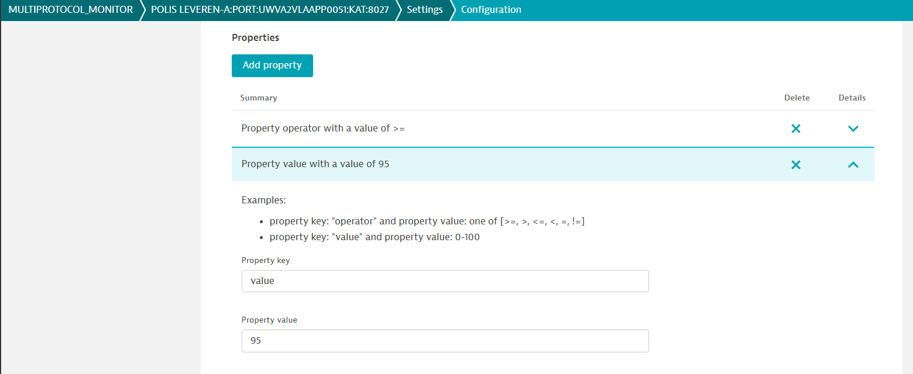

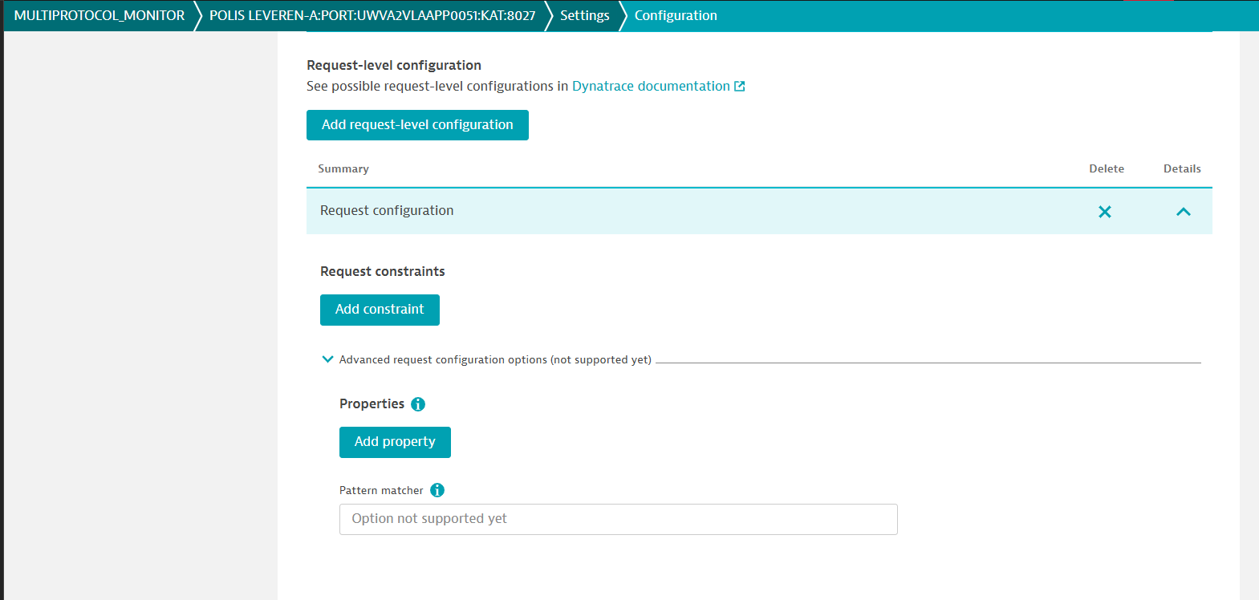

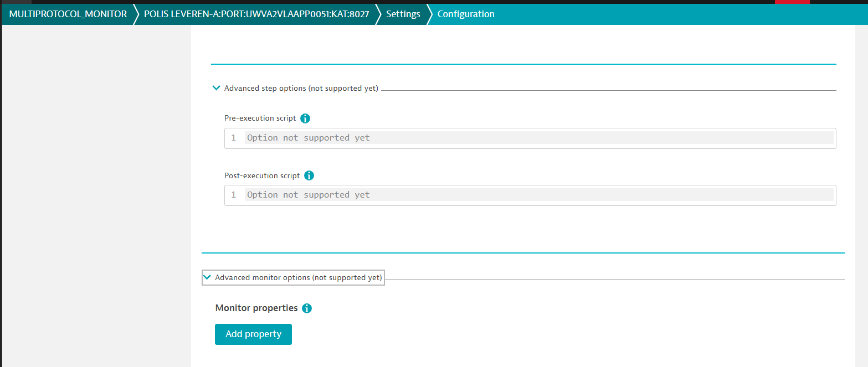

1. Select the Frequency and locations.

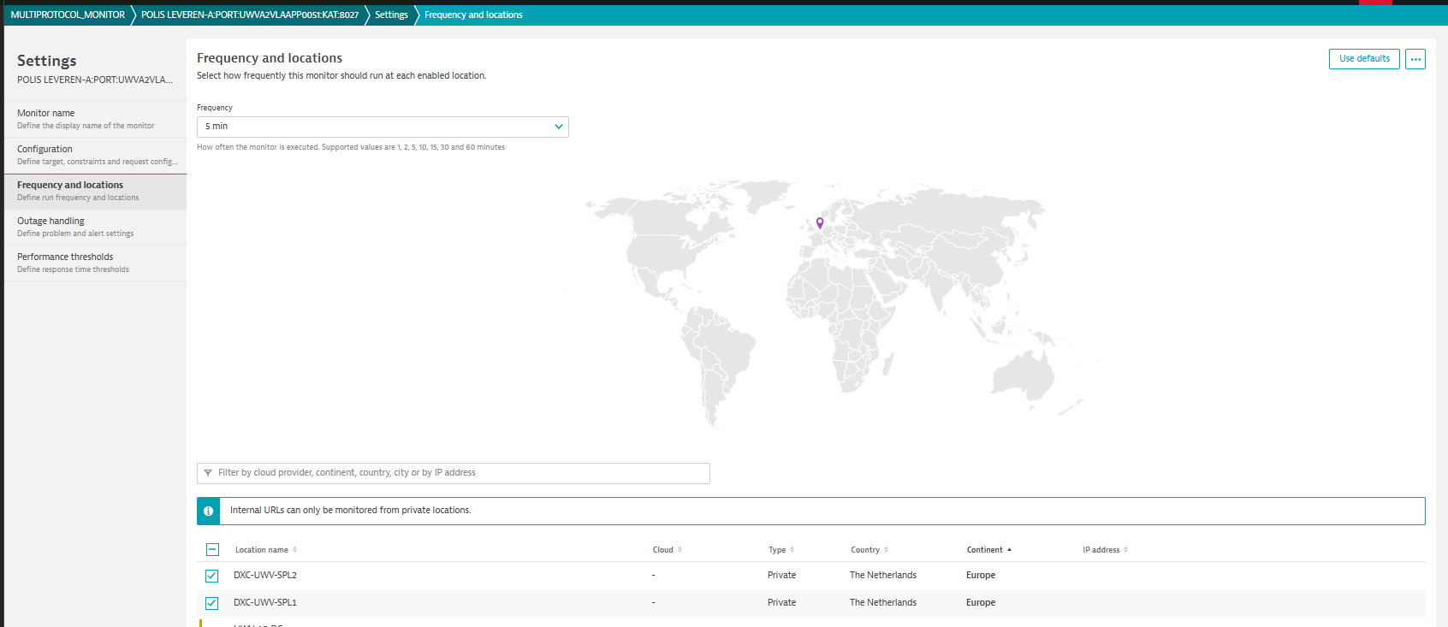

1. Set up the Outage handling.

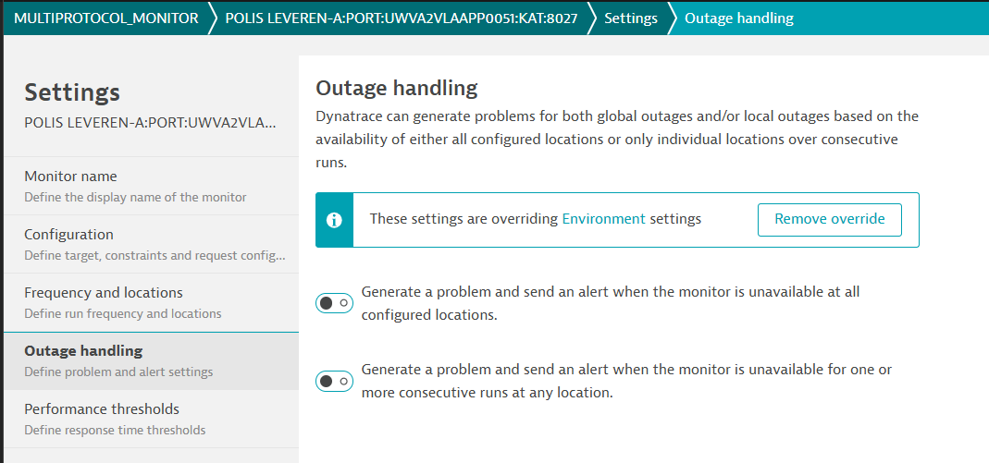

1. Set up the Performance threshold.

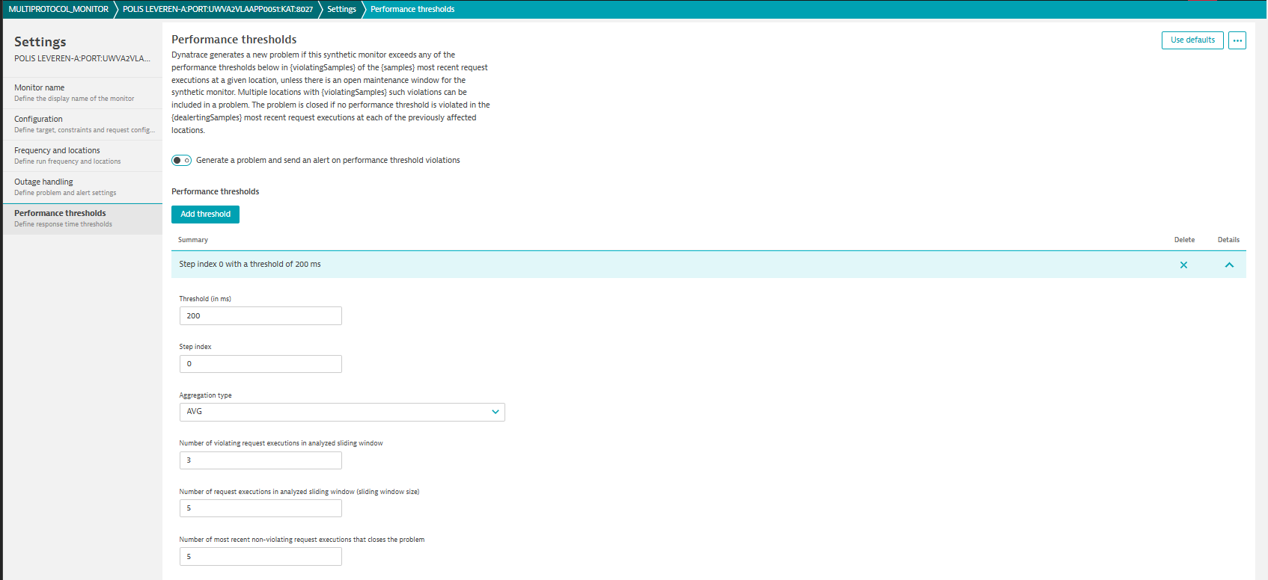

1. Output.

